**Business Rules:**

In a University, there are several departments and each department has a head of department who belongs to Faculty. Department have a name, phone Number, specific mailing address and Students that belong to the department. Students can belong to only one Department at a time and Department can have more than one or no Student Students and faculty have names and unique id numbers , with address , age , and gender. Student studies different Courses offered by University. Faculty teaches these Courses. Faculty members can teach in multiple Departments. Each course can be taught by many faculty members or no one Faculty members are also working on multiple research projects. These projects are funded by government and university. One project can have more than one faculty member and one faculty member can work on more than one project.

**Noun & Verb Analysis:**

**Nouns:**

* Department
* Faculty
* Student
* Courses
* Research Projects

**Verbs:**

* Department **belongs to** Faculty.
* Students **belong to** the departments. (A department could have more than one students)
* Student **studies** different Courses. (Student can take more than one course.)
* Faculty **teaches** these Courses. (Faculty can teach more than one courses.)
* Faculty members are **working** on multiple research projects.

**Entities & Attributes:**

**Student**: Name, age, gender, address, phone Number, Roll Number, Course Code.

**Faculty**: Name, age, gender, address, phone Number, Course Code, Grade, Salary, Faculty ID and designation.

**Course:** Name, Student ID, Faculty ID, Department ID and Course Code.

**Department:** Name, Student ID, Faculty ID and Department ID.

**Research Project**: Project ID, Faculty ID, Name, Duration.

**Relational Model:**

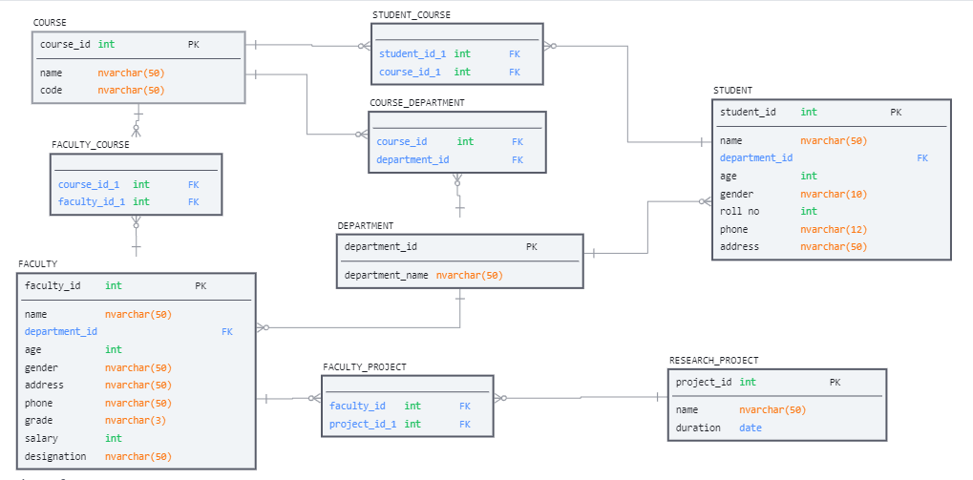

**Queries:**

use master

go

DROP DATABASE University_Management_System

GO

CREATE DATABASE University_Management_System

GO

USE University_Management_System

GO

CREATE TABLE DEPARTMENT

(

    department_id INT NOT NULL, CONSTRAINT pk_department_id PRIMARY KEY (department_id),

    department_name NVARCHAR(50) NOT NULL,

);

GO

CREATE TABLE STUDENT

(

    student_id INT NOT NULL, CONSTRAINT pk_student_id PRIMARY KEY (student_id),

    student_name NVARCHAR(50) NOT NULL,

    department_id INT NULL,

    age INT NOT NULL,

    gender NVARCHAR(10) NOT NULL,

    phone NVARCHAR(12) NULL,

    address NVARCHAR(50) NULL,

    CONSTRAINT fk_department_id FOREIGN KEY (department_id) REFERENCES DEPARTMENT(department_id)

);

GO

CREATE TABLE COURSE

(

    course_code INT NOT NULL, CONSTRAINT pk_course_id PRIMARY KEY (course_code),

    course_name NVARCHAR(50) NOT NULL

);

GO

CREATE TABLE COURSE_DEPARTMENT

(

    course_code INT NULL,

    department_id INT NULL,

    CONSTRAINT fk_course_code FOREIGN KEY (course_code) REFERENCES COURSE(course_code),

    CONSTRAINT fk_department_id1 FOREIGN KEY (department_id) REFERENCES DEPARTMENT(department_id)

);

GO

CREATE TABLE STUDENT_COURSE

(

    student_id INT NULL,

    course_code INT NULL,

    CONSTRAINT fk_course_code1 FOREIGN KEY (course_code) REFERENCES COURSE(course_code),

    CONSTRAINT fk_student_id FOREIGN KEY (student_id) REFERENCES STUDENT(student_id),

);

GO

CREATE TABLE FACULTY

(

    faculty_id INT NOT NULL, CONSTRAINT pk_faculty_id PRIMARY KEY (faculty_id),

    name NVARCHAR(50) NOT NULL,

    department_id INT NULL,

    age INT NOT NULL,

    gender NVARCHAR(10) NOT NULL,

    address NVARCHAR(50) NULL,

    phone NVARCHAR(12) NULL,

    salary float NOT NULL,

    designation NVARCHAR(50) NOT NULL,

    CONSTRAINT fk_department_id2 FOREIGN KEY (department_id) REFERENCES DEPARTMENT(department_id)

);

GO

CREATE TABLE FACULTY_COURSE

(

    course_code INT NULL,

    faculty_id INT NULL,

    CONSTRAINT fk_course_code2 FOREIGN KEY (course_code) REFERENCES COURSE(course_code),

    CONSTRAINT fk_faculty_id FOREIGN KEY (faculty_id) REFERENCES FACULTY(faculty_id)

);

GO

CREATE TABLE RESEARCH_PROJECT

(

    project_id INT NOT NULL, CONSTRAINT pk_project_id PRIMARY KEY (project_id),

    project_name NVARCHAR(50) NOT NULL,

    duration NVARCHAR(10) NULL,

);

GO

CREATE TABLE FACULTY_PROJECT

(

    faculty_id INT NULL,

    project_id INT NULL,

    CONSTRAINT fk_faculty_id1 FOREIGN KEY (faculty_id) REFERENCES FACULTY(faculty_id),

    CONSTRAINT fk_project_idd FOREIGN KEY (project_id) REFERENCES RESEARCH_PROJECT(project_id)

);

GO

--*************************************************************--

INSERT INTO DEPARTMENT (department_id, department_name)

VALUES

(1, 'COMPUTER SCIENCE'),

(2, 'PHSYCOLOGY'),

(3, 'HISTORY'),

(4, 'POLITICAL SCIENCE'),

(5, 'ENGLISH'),

(6, 'PYHYSCIAL SCIENCE')

GO

INSERT INTO STUDENT (student_id,student_name,department_id,age ,gender,phone , address)

VALUES

(310,'Ameer Hamza',1,19,'Male','03207174918','Lahore'),

(328,'Safdar Ali',1,20,'Male','03287204918','Haveli Lakha'),

(326,'Qamar Munir',1,18,'Male','03338161674','Sialkot'),

(676,'Khansa',2,18,'Female','03444647859','Lahore'),

(678,'Mateen Ahmed',2,21,'Male','03321495546','Islamabad'),

(410,'Ali Raza',3,21,'Male','03113636489','Hafizabad'),

(414,'Afiafa',3,23,'Female','03487865120','Islamabad'),

(426,'Bilal Ahmed',3,24,'Male','03321491834','Karachi'),

(514,'Safdar Ijaz',4,19,'Male','031131827449','Lahore'),

(578,'Afiafa',4,23,'Female','03487865120','Islamabad'),

(596,'Bilal Ahmed',5,24,'Male','03321491834','Karachi'),

(777,'Noor',5,20,'Female','03115478457','Guujranwala'),

(776,'Munir Ahmed',5,25,'Male','03816475224','Rawalapindi'),

(769,'Abdul Ali',5,24,'Male','03321491834','Karachi'),

(810,'Ali Ashraf',5,22,'Male','03321491834','Islamabad'),

(888,'Asma Kanwal',6,24,'Female','03212121495','Nankana Sahab'),

(826,'Naveed Ahmed',6,19,'Male','03114934854','Okara');

GO

INSERT INTO COURSE (course_code,course_name)

VALUES

(111,'C++'),

(112,'OOP'),

(113,'Applied Physics'),

(114,'Maths'),

(115,'Database System'),

(116,'Data Structure'),

(117,'Communicaition Skills'),

(221,'English'),

(222,'Sexiology'),

(223,'Experimental Psychology'),

(224,'Statistics'),

(331,'Introduction to History'),

(332,'Computer Skills'),

(333,'Environment of Pakistan'),

(441,'Pakistan Studies'),

(442,'Understanding Political Theory'),

(443,'Comparative Politics'),

(444,'Political Theory'),

(511,'Creative Writing'),

(522,'Poetry'),

(533,'Jouranlism'),

(544,'Linguistics'),

(661,'Astronomy'),

(662,'Earth Sciences'),

(663,'Geology')

GO

INSERT INTO STUDENT_COURSE (course_code,student_id)

VALUES

(111,310),(112,310),(113,310),(114,310),(115,310),(116,310),

(113,328),(114,328),(115,328),(116,328),(117,328),(113,328),

(114,326),(115,326),(116,326),(117,326),(221,676),(222,676),

(223,678),(221,678),(222,678),(332,410),(333,410),(331,426),

(332,426),(333,426),(441,514),(442,514),(443,514),(444,514),

(441,578),(444,578),(441,596),(442,596),(443,596),(511,776),

(522,776),(533,776),(544,776),(114,776),(533,769),(544,769),

(114,769),(511,777),(522,777),(533,777),(661,810),(662,810),

(661,888),(662,888),(663,888),(661,826),(662,826),(663,826)

GO

INSERT INTO FACULTY(faculty_id,name,department_id,age,gender,address,phone,salary,

designation)

VALUES

(1,'Asad Raza',1,50,'Male','Lahore','095115155511',150000,'Head of Department'),

(2,'Hafeez Ahmed',1,25,'Male','Ali Pur Chattha','03354565951',250000,'Chaiperson'),

(3,'Yahya Khuram',1,35,'Male','Sialkot','01535154851',25000,'Lecturer'),

(4,'Muhammad Sufyan',2,40,'Male','hafizabad','04681648521',50000,'Assitant Professor'),

(5,'Ashraf Nazir',2,26,'Male','Jhang','031515151515',15000,'Lecturer'),

(6,'Ali Raza Kazmi',3,29,'Male','Sarghoda','0331515151',60000,'Lecturer'),

(7,'Asad Ullah',3,31,'Male','Gujranwala','03818181212',152000,'Head of Department'),

(8,'Illyas Fakhir',3,32,'Male','Swat','0920136541',180000,'Assitant Professor'),

(9,'Amina Tahir',1,45,'female','Sibi','03354565951',157000,'Assitant Professor'),

(10,'Asma Kanwal',2,35,'female','Gujrat','032362518',122200,'Assitant Professor'),

(11,'Sehrish Iftikhar',3,35,'female','Multan','031919191919',25000,'Lecturer'),

(12,'Fariha Naqvi',4,34,'female','Gujranwala','0358142536',125000,'Head of Department'),

(13,'Saeed ur Rehman',4,25,'Male','Karachi','0348618521',195550,'Assistant Professor'),

(14,'Aleem Khan',4,26,'Male','Checha Watni','0315486294',17000,'Lecturer'),

(15,'Ijaz Bukhari',4,28,'Male','Havelian','03354565951',170000,'Lecturer'),

(16,'Imtiaz Yousaf',5,22,'Male','Islamabad','03358888951',19000,'Lecturer'),

(17,'Ameer Hamza',5,23,'Male','Multan','03565951333',15000,'Lecturer'),

(18,'Shahid Majeed',5,23,'Male','Hafizabad','03369695951',157700,'Head of Department'),

(19,'Aleem Dar',5,22,'Male','Jhang','03356484751',35000,'Assitant Professor'),

(20,'Muhammad Idress',5,40,'Rawalpindi','Lahore','03378963221',50000,'Assitant Professor'),

(21,'Umair Aslam',6,21,'Male','Sialkot','033511111111',70000,'Head of Department'),

(22,'Usman Hanif',6,23,'Male','Gujranwala','03020202020',800000,'Assistant Professor'),

(23,'Muhammad Ishtiyaq',6,29,'Male','Swat','0339147896',90000,'Assitant Professor')

GO

INSERT INTO FACULTY_COURSE(course_code,faculty_id)

VALUES

(111,2),(112,2),(113,1),(114,3),(115,2),(116,3),(117,1),(221,4),

(222,4),(223,5),(224,10),(331,6),(332,7),(333,8),(441,12),(442,13),

(443,14),(444,15),(511,16),(522,17),(533,18),(544,19),(661,21),

(662,22),(663,23)

GO

INSERT INTO RESEARCH_PROJECT(project_id ,project_name ,duration )

VALUES

(1,'Artificial Intelligence', '2021-24'),

(2,'Cyber Security', '2020-22'),

(3,'Rural Banking', '2021-23'),

(4,'Social cognition', '2021-23'),

(5,'Person perception.', '2021-23'),

(6,'Attitudes', '2021-23'),

(7,'Cultures of Knowledge', '2021-23'),

(8,'Everyday Life and Fatal', '2021-23'),

(9,'Soviet Union Ideology', '2021-23'),

(10,'Climate Change', '2021-23'),

(11,'Global Warming', '2021-23'),

(12,'Hydro Power', '2021-23')

GO

INSERT INTO FACULTY_PROJECT(faculty_id,project_id)

VALUES

(1,1),(2,1),(3,2),(4,4),(5,5),(6,7),(7,7),(8,8),(9,3),(10,6),(11,8),

(12,9),(13,9),(15,9),(16,10),(17,11),(18,10),(19,11),(21,12),(23,12)